2018 Counseling Graduate Student Conference
Hosted by: Liberty University Saturday, February 17, 2018
(Inclement Weather Date: March 03, 2018)

CALL FOR PROGRAMS

Guidelines and Information:
The VACES Graduate Student Conference is being sponsored by Liberty University located in Lynchburg, Virginia in the Arthur S. DeMoss Learning Center (4th Floor).

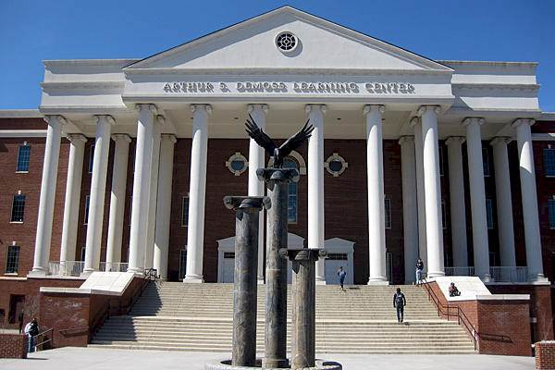

- Proposals will be accepted for presentations and poster sessions.
- Presentations can be in the following format:
  - 50 minutes
  - Poster sessions (30 minutes)
- Any topics of interest or importance to the profession of counseling will be considered: school, agency, marriage and family, career, supervision, ethics, professional identity, mental health, clinical practice, research, substance abuse, etc.
- Only Doctoral and Master’s level counseling students currently enrolled in a Counselor Education program are eligible to present.
- Complete the program proposal page and return as an electronic attachment in word document format to: jharrichand@liberty.edu
- Deadline for submissions is midnight November 10, 2017
- Late and incomplete proposals will not be considered.
- You will be notified by email regarding acceptance by no later than midnight December 01, 2017.
- If you are selected to present, all presenters on your presentation are required to register and pay for this conference. The cost is $35 before February 7, 2018 or $45 on-site.
*More information, along with hotels in the area, will be sent with your acceptance notification.
- If you have questions or need additional information, please contact:
Dr. Joy Mwendwa at jmmaweu@liberty.edu or Mr. John Harrichand at jharrichand@liberty.edu

Presentation Application
2018 Counseling Graduate Student Conference
Hosted by: Liberty University Saturday, February 17, 2018
(Inclement Weather Date: March 03, 2018)

Master’s Student
Doctoral Student Graduate Student Lead
Presenter: College/University: E-mail:
*All correspondence regarding the conference will be sent to the Lead presenter’s e-mail (listed above). It is the responsibility of the Lead Presenter to notify all co-presenters of the acceptance/rejection and scheduling information related to the conference. *
Additional Presenters (Limit 3):
- First Co-presenter:

- Second Co-presenter:

3) Third Co-presenter:

*In the space below, please indicate the name of the faculty member at your institution who has supported your work on this proposal or who has been of significant importance to you during your counseling studies. This faculty member will be invited to attend the conference as a guest of VACES. *
Faculty Sponsor:

Faculty Sponsor’s E-mail:

Type of Proposal (Please check ONE):

Educational Session (50 minutes)
Poster Session (30 minutes)
Title:

Summary/Description (75 word limit). This description will be printed in the program.

List three learning objectives for your presentation/poster:

1)

2)

3)

Return the proposal as an electronic attachment in word document format to: jharrichand@liberty.edu
*On the email subject line, please write the following so we can track your emails: “2018 VACES + Your full Name”
Example: “2018 VACES JoyMwendwa”

